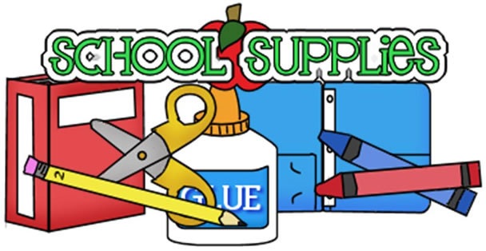
- 1 ½” Durable View Binder (must have clear front view pocket)
- 24 count box of Crayola crayons
- 12 count box of Crayola colored pencils
- 4/Pack Expo Dry-Erase Markers
- 2 dozen #2 Pencils
- 2 soft zipper Pencil Cases (with binder holes)
- 2/pack Glue Sticks
- Ear buds or earphones (required for laptop use)
- 1 box of tissues
- 5 Plastic Folders with binder holes
- 3 Marble Composition Books

Classroom Wish List Items:
Lysol Wipes
Hand Sanitizer
Boxes of Tissues
Flash Drive
#2 Pencils
Dry-Erase Markers

